Cross-quantilogram: EURUSD and NZDUSD
Method 20 / daily log returns / expanding quantiles / Alpari D1 full available history

Study setup
Logical pair: EURUSD , NZDUSD
Broker symbols: EURUSD_i , NZDUSD_i
Snapshot: 2026-11-03_majors_alpari_D1
Timeframe: D1
Matched return window: 1999-01-05 to 2026-11-02 (UTC bar dates)
Matched return count n: 7186
Dropped unfinished last bar dated 2026-11-03 UTC after a tick-volume check against the prior complete day.
Quantiles: expanding window, min history 252 days
tau in [0.05, 0.2]; k=0..10; headline tau=0.05, k=1
Complete matched rows (Excel): EURUSD-NZDUSD_CQ_D1.xlsx
Complete matched rows (HTML table): EURUSD-NZDUSD_CQ_D1_data.html

Method carried forward
The cross-quantilogram rho_tau(k) measures linkage among centered quantile-hit indicators of matched daily log returns of close, ln(close_t / close_t-1). Quotes are not inverted. At each date t, the tau-quantile uses only returns through t (expanding window) after a minimum history of 252 days. Hits are h_t = 1(r_t < q_t) - tau. rho_tau(k) is the normalized cross-product of h_x,t with h_y,t+k. Levels tau in {0.05, 0.20} and lags k=0..10 are pre-specified; headline is tau=0.05, k=1 both directions. Same-sample Pearson r is a side check. This is not causation and not a trading signal.

Results (headline)
rho_EURUSD->NZDUSD(tau=0.05,k=1): 0.078794
rho_NZDUSD->EURUSD(tau=0.05,k=1): 0.063295
rho_EURUSD->NZDUSD(tau=0.20,k=1): 0.067389
rho_NZDUSD->EURUSD(tau=0.20,k=1): 0.020071
Pearson r: 0.549808

CQ table (tau=0.05)
k | rho_EURUSD_to_NZDUSD | n_EURUSD_to_NZDUSD | rho_NZDUSD_to_EURUSD | n_NZDUSD_to_EURUSD
0 | 0.26866531 | 6935 | 0.26866531 | 6935
1 | 0.07879376 | 6934 | 0.06329462 | 6934
2 | 0.04778626 | 6933 | 0.02841214 | 6933
3 | 0.04390218 | 6932 | 0.05940162 | 6932
4 | 0.03614312 | 6931 | 0.04389292 | 6931
5 | 0.03225885 | 6930 | 0.06325834 | 6930
6 | 0.03999943 | 6929 | 0.04774938 | 6929
7 | 0.07486524 | 6928 | 0.04386514 | 6928
8 | 0.05935609 | 6927 | 0.03610578 | 6927
9 | 0.0515968 | 6926 | 0.04384662 | 6926
10 | 0.03996224 | 6925 | 0.04771249 | 6925

Conclusion
Headline tau=0.05, k=1 for EURUSD and NZDUSD: rho_EURUSD->NZDUSD = 0.0788; rho_NZDUSD->EURUSD = 0.0633. At tau=0.20, k=1: 0.0674 and 0.0201. Same-day tau=0.05 rho(k=0) = 0.2687. Pearson r = 0.5498. This is quantile-hit linkage, not a trading signal.

Charts
Daily closes

Daily log returns

Cross-quantilogram tau=0.05
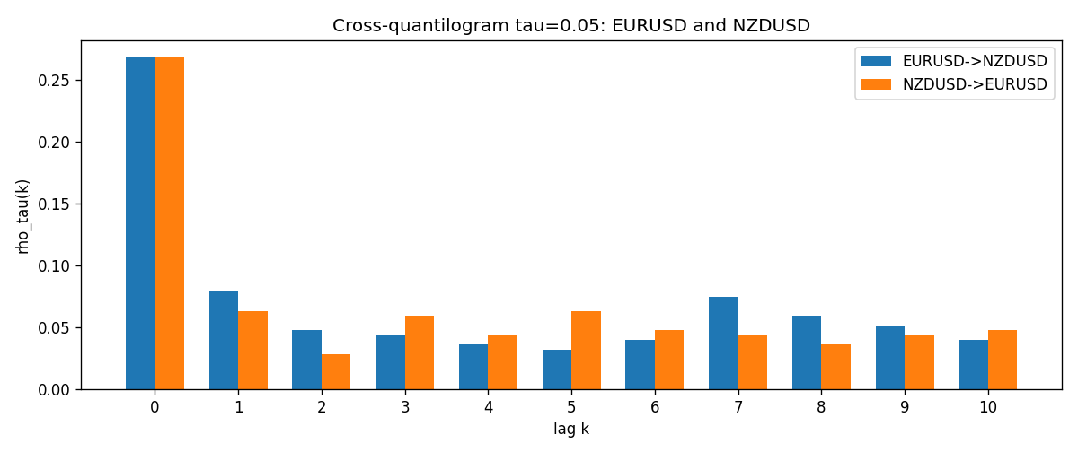

Data report
Matched rows and the CQ sheet are in the sibling Excel workbook named EURUSD-NZDUSD_CQ_D1.xlsx. Embedding all rows as a Word table is impractical; this file holds column summaries and the first and last 15 matched rows.
Columns: time, EURUSD_open, NZDUSD_open, EURUSD_high, NZDUSD_high, EURUSD_low, NZDUSD_low, EURUSD_close, NZDUSD_close, EURUSD_tick_volume, NZDUSD_tick_volume, EURUSD_spread, NZDUSD_spread, EURUSD_real_volume, NZDUSD_real_volume, EURUSD_log_return, NZDUSD_log_return, EURUSD_h_t005, NZDUSD_h_t005
Column summaries (matched calculation rows)
column | count | mean | std | min | 25% | 50% | 75% | max
EURUSD_open | 7186 | 1.181357 | 0.15085833 | 0.8272 | 1.086165 | 1.16609 | 1.2939475 | 1.5995
NZDUSD_open | 7186 | 0.65641776 | 0.10819833 | 0.3913 | 0.59134 | 0.6684 | 0.7249075 | 0.88218
EURUSD_high | 7186 | 1.1864878 | 0.15145386 | 0.8326 | 1.09024 | 1.17121 | 1.2993075 | 1.6038
NZDUSD_high | 7186 | 0.66033433 | 0.10869188 | 0.3961 | 0.59475 | 0.67202 | 0.72936 | 0.88421
EURUSD_low | 7186 | 1.1763494 | 0.15017707 | 0.8227 | 1.082045 | 1.162475 | 1.2884175 | 1.5865
NZDUSD_low | 7186 | 0.65273031 | 0.10779283 | 0.3897 | 0.5880725 | 0.664185 | 0.720965 | 0.87988
EURUSD_close | 7186 | 1.1813978 | 0.15082738 | 0.8267 | 1.0860425 | 1.16602 | 1.2939725 | 1.5997
NZDUSD_close | 7186 | 0.65649194 | 0.10819527 | 0.3907 | 0.59159 | 0.66842 | 0.725015 | 0.8822
EURUSD_tick_volume | 7186 | 103205.25 | 173535.32 | 218 | 9413.25 | 52774.5 | 99579.75 | 1471626
NZDUSD_tick_volume | 7186 | 68709.014 | 123134.25 | 16 | 5585.5 | 33893.5 | 58510.5 | 1127682
EURUSD_spread | 7186 | 19.350682 | 16.562781 | 0 | 8 | 12 | 27.5 | 50
NZDUSD_spread | 7186 | 30.284303 | 25.649992 | 0 | 9 | 17 | 47.5 | 80
EURUSD_real_volume | 7186 | 4.0330482e+10 | 1.6691688e+11 | 0 | 0 | 0 | 0 | 3.6149665e+12
NZDUSD_real_volume | 7186 | 1.6701379e+10 | 8.497804e+10 | 0 | 0 | 0 | 0 | 2.705649e+12
EURUSD_log_return | 7186 | -4.99e-06 | 0.00579654 | -0.03123819 | -0.00323792 | 0 | 0.00325328 | 0.03433183
NZDUSD_log_return | 7186 | 9.3e-06 | 0.0076423 | -0.07027433 | -0.00425367 | 0.00022883 | 0.00457975 | 0.05966839
EURUSD_h_t005 | 6935 | -0.0165465 | 0.17983054 | -0.05 | -0.05 | -0.05 | -0.05 | 0.95
NZDUSD_h_t005 | 6935 | -0.0055876 | 0.20602442 | -0.05 | -0.05 | -0.05 | -0.05 | 0.95
First 15 matched rows (selected columns)
time | EURUSD_log_return | NZDUSD_log_return | EURUSD_h_t005 | NZDUSD_h_t005
1999-01-05 | -0.0048360507 | -0.0018597736 | nan | nan
1999-01-06 | -0.011547966 | 0.0020455609 | nan | nan
1999-01-07 | 0.0076280636 | 0.0062963171 | nan | nan
1999-01-08 | -0.010902799 | -0.00055396548 | nan | nan
1999-01-11 | -0.007103287 | 0.010290425 | nan | nan
1999-01-12 | 0.0045103728 | -0.0053157489 | nan | nan
1999-01-13 | 0.010845346 | -0.0099742238 | nan | nan
1999-01-14 | 0 | -0.00018564931 | nan | nan
1999-01-15 | -0.010153245 | -0.00074294208 | nan | nan
1999-01-18 | 0.0036256946 | -0.0018597736 | nan | nan
1999-01-19 | -0.00017235436 | 0.0018597736 | nan | nan
1999-01-20 | -0.0031939256 | 0.0040793678 | nan | nan
1999-01-21 | 0.0030215416 | 0.0040627941 | nan | nan
1999-01-22 | -0.0012075213 | -0.012051689 | nan | nan
1999-01-25 | -0.0030251979 | -0.0035504102 | nan | nan
Last 15 matched rows (selected columns)
time | EURUSD_log_return | NZDUSD_log_return | EURUSD_h_t005 | NZDUSD_h_t005
2026-10-13 | 0.0037402957 | 0.0047326165 | -0.05 | -0.05
2026-10-14 | -0.0037582255 | -0.0037306483 | -0.05 | -0.05
2026-10-15 | 0.0056053107 | 0.0047634855 | -0.05 | -0.05
2026-10-16 | 0.0017724895 | 0.0057501001 | -0.05 | -0.05
2026-10-19 | -0.0025394633 | 0.0018917133 | -0.05 | -0.05
2026-10-20 | 0.0023881672 | 0.0037199341 | -0.05 | -0.05
2026-10-21 | -0.00032046717 | 0.0030923331 | -0.05 | -0.05
2026-10-22 | -0.0015949606 | -0.0033035227 | -0.05 | -0.05
2026-10-23 | -0.001338521 | 0.0030929853 | -0.05 | -0.05
2026-10-26 | -0.0022706559 | -0.0028993932 | -0.05 | -0.05
2026-10-27 | -0.004152342 | -0.00026399852 | -0.05 | -0.05
2026-10-28 | 0.0022262927 | -0.0097283914 | -0.05 | -0.05
2026-10-29 | 0.0022571351 | 0.00062190714 | -0.05 | -0.05
2026-10-30 | -0.0011458446 | 0.00019537668 | -0.05 | -0.05
2026-11-02 | 0.002120569 | -0.0025962955 | -0.05 | -0.05

